CPE301 – SPRING 2020

MIDTERM 1

Student Name: Do Le

Student #: 2001183621

Student Email: [led2@unlv.nevada.edu](mailto:led2@unlv.nevada.edu)

Primary Github address: <https://github.com/DoVietLe>

Directory: <https://github.com/DoVietLe/assignments>

Submit the following for all Labs:

1. In the document, for each task submit the modified or included code (only) with highlights and justifications of the modifications. Also, include the comments.
2. Use the previously create a Github repository with a random name (no CPE/301, Lastname, Firstname). Place all labs under the root folder ESD301/Midterm, sub-folder named LABXX, with one document and one video link file for each lab, place modified asm/c files named as LabXX-TYY.asm/c.
3. If multiple asm/c files or other libraries are used, create a folder LabXX-TYY and place these files inside the folder.
4. The folder should have a) Word document (see template), b) source code file(s) and other include files, c) text file with youtube video links (see template).

Q: Write, simulate, and demonstrate using Atmel Studio 7 a C code for the AVR ATMEGA328p microcontroller that performs the following functions:

1. Program the UART Module to interact with the ATmega328/p:

2. On transmitting the following keys from the host terminal, the following actions will be performed:

1. On-reboot or ‘h’ key – help screen (list all keys and functionalities)

2. ‘t’ display temperature in C of LM34/35 on terminal, ‘T’ - display temperature in F of LM34/35 on terminal.

3. ‘o’ turns ON LED at PB5, ‘O’ turns OFF the LED at PB5.

4. ‘s’ sends a string to the terminal.

5. ‘i’ sends an integer to the terminal. Use the integer as a delay in seconds to blink the LED PB2.

1. **COMPONENTS LIST AND CONNECTION BLOCK DIAGRAM w/ PINS**

Components

• Xplained Mini Board

* + ATmega328PB
  + Programmer
  + Debugger

• Arduino Multifunction Shield

• LM35 Temperature Sensor

• Atmel Studios 7.0

* + Compiler
  + Serial Monitor

Block Diagram

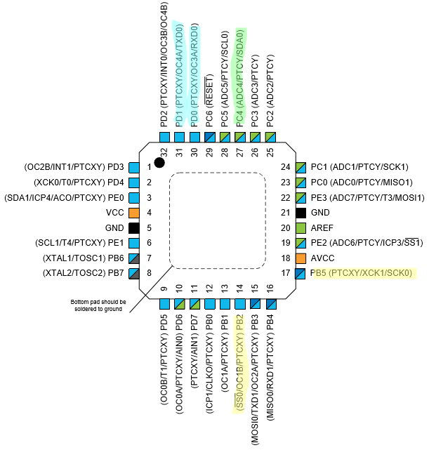

PD0 and PD1 used for serial communication

PB2 and PB5 used for LEDs

PC4 used for analog to digital

1. **INITIAL/MODIFIED/DEVELOPED CODE OF TASK 1/A**

Code

#include <avr/interrupt.h>

#include <avr/io.h>

#define CYCLES_1s 15624 // Amount of cycles for 1s delay @16MHz, 1024 pre-scaler.

#define UBBR_VALUE 103

// Lists the functionalities.

const char functionalities[] = "h - Help screen \n"

"t - Display temperature in centrigrade \n"

"T - Display temperature in fahrenheit \n"

"o - Turn on PB5 LED \n"

"O - Turn off PB5 LED \n"

"s - Send a string to the terminal \n"

"i - Send an integer to the terminal \n\n";

const char myString[] = "CPE 301 Midterm.\n";

// Keeps track of the delay between blinks of LED on PB2. Initialized to 1s.

volatile int delayAmount = 0;

volatile int delayMax = 1;

// Stores the temperature as a string.

volatile char temperatureString[10];

volatile char integer[10];

void enableRandomTimer() {

// Enables timer in normal mode with a pre-scaler of 1024.

TCCR0A = 0x00;

TCCR0B = 0x05;

}

*uint8_t* getInt() {

*uint8_t* num = TCNT0;

num ^= (num<<(num%8));

return num % 10;

}

void initializeBlinkingLED() {

// Sets PB2 as output.

DDRB |= (1<<2);

PORTB &= ~(1<<2);

// Set interrupt settings.

OCR1A = CYCLES_1s;

TIMSK1 = 0b00000010; // Enables interrupt on compare match A.

TIFR1 |= 0x02; // Clears the interrupt flag.

sei();

// Sets timer settings.

TCCR1B = 0b00001101; // Sets timer1 to be in CTC mode with 1024 pre-scaler.

TCCR1A = 0b00000000;

TCNT1 = 0;

}

// Enables ADC.

void enableADC() {

// Sets PINC4 as input.

DDRC &= ~(1<<4);

// Sets up ADC settings.

ADMUX = 0xC4; // Reads from ADC4. Right justified. Internal 1.1V reference.

ADCSRB = 0x00; // Free running mode.

ADCSRA = 0b10000111; // Enables ADC with 128 pre-scaler.

}

// Disables ADC.

void disableADC() {

ADCSRA &= 0x7F; // Disables the ADEN bit.

}

// Converts an analog to digital value on PC0.

*uint16_t* analogRead() {

ADCSRA |= (1<<6); // Enables ADSC to start AD conversion.

while (!(ADCSRA&(1<<4))); // Waits until ADIF is set indicating ADC is done.

ADCSRA |= (1<<4); // Clears ADIF flag.

return ADC; // Returns value.

}

// Uses a formula to convert a digital read value to temperature (formula works for 1.1V reference voltage).

float analogToTemp(*uint16_t* t, char unit) {

// Takes analog converted number and converts it into temperature.

//return t;

float convertedTemp = t*110/1023;

switch (unit) {

case 't':

return convertedTemp; // Returns temperature in Celsius.

case 'T':

default:

return convertedTemp*1.8 + 32; // Returns temperature converted to Fahrenheit.

}

}

*uint8_t* asciiToInt8(*uint8_t* n) {

if (n >= 48 && n <= 57) {

sendByte();

return n - 48;

}

return 1;

}

// Sets up UART.

void setUART() {

// Sets port.

DDRD |= 0x02;

// Sets baud rate.

UBRR0 = UBBR_VALUE;

// Sets UART settings.

UCSR0C |= 0b00000110; // to async mode with no parity

}

// Enables transmitter on PORTD1.

void enableTransmit() {

// Sets port.

DDRD |= 0x02;

UCSR0B |= 0b00001000; // Enables transmit line.

}

// Disables the transmitter on UART.

void disableTransmit() {

UCSR0B &= ~(1<<TXEN0);

}

// Enables receiver on PORTD0.

void enableReceive() {

// Sets port.

DDRD &= ~1;

UCSR0B |= (1<<RXEN0); // Enables receive line.

}

// Sends one byte of data out the TX line.

void sendByte(*uint8_t* b) {

if (UCSR0B & (1<<TXEN0)) { // Checks whether transmit is enabled.

while (!(UCSR0A & (1<<UDRE0))); // Waits until the UDR0 register is ready.

UDR0 = b; // Sends the byte.

}

}

// Sends every ASCII byte in a string.

void sendString(char string[]) {

int i = 0;

while (string[i] != '\0')

sendByte(string[i++]);

}

char getByte() {

while (!(UCSR0A & (1<<7))); // Waits until the data is fully received.

return UDR0;

}

int main(void)

{

// Sets everything up.

enableRandomTimer();

enableADC();

setUART();

enableTransmit();

enableReceive();

initializeBlinkingLED();

DDRB |= (1<<5); // Enables PB5 and PB2 for the LEDs.

PORTB &= ~(1<<5);

sendString(functionalities);

while (1) {

// Polls for a serial data on the RX line.

char instr = getByte();

// When data is sent, perform something based on the instructions

// if the instruction is defined. Otherwise, poll again.

if (instr == 'h') {

sendString(functionalities);

} else if (instr == 't' || instr == 'T') {

*uint16_t* temp = analogRead(); // Reads in temperature and converts.

float convertedTemp = analogToTemp(temp, instr);

*snprintf*(temperatureString, 10, "%f\n", convertedTemp);

sendString(temperatureString);

sendByte('\n');

} else if (instr == 'o') {

PORTB &= ~(1<<5); // Turns on LED.

} else if (instr == 'O') {

PORTB |= (1<<5); // Turns off LED.

} else if (instr == 's') {

sendString(myString);

} else if (instr == 'i') {

*uint8_t* num = getInt(); // Grabs a random integer.

*snprintf*(integer, 10, "%d\n", num);

sendString(integer); // Sends the integer to the terminal.

sendByte('\n');

delayMax = num; // Replaces delay with new integer.

}

}

}

ISR(TIMER1_COMPA_vect) {

TIFR1 |= 0x02; // Clears interrupt flag.

delayAmount = (delayAmount + 1) % delayMax;

if (delayAmount == 0)

PORTB ^= (1<<2); // Toggles PB2.

}

1. **DEVELOPED MODIFIED CODE OF TASK 2/A from TASK 1/A**

There is no modified code.

1. 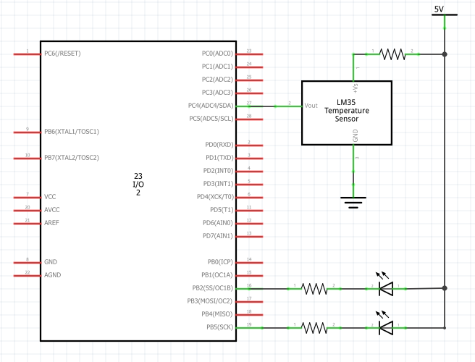**SCHEMATICS**
2. **SCREENSHOTS OF EACH TASK OUTPUT (ATMEL STUDIO OUTPUT)**
3. **SCREENSHOT OF EACH DEMO (BOARD SETUP)**

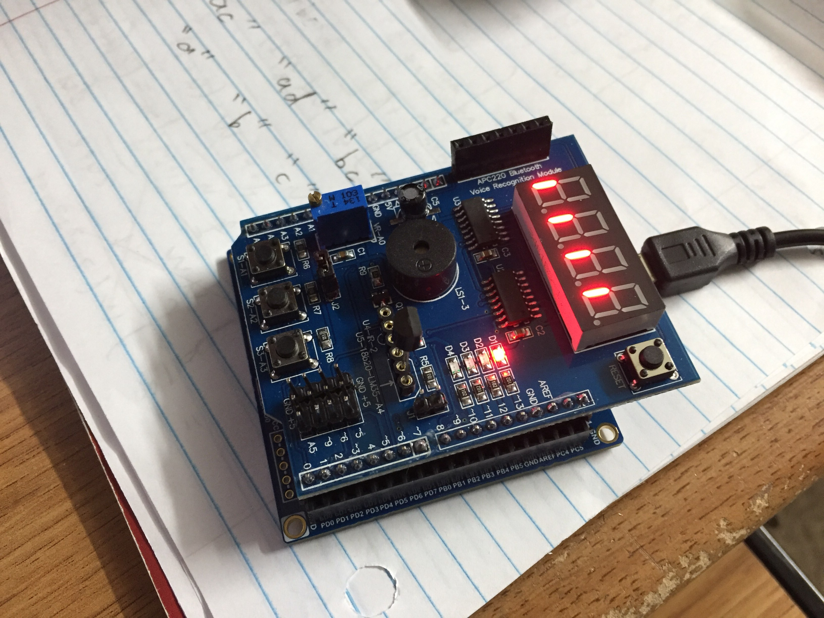

1. **VIDEO LINKS OF EACH DEMO**

Video Link

https://www.youtube.com/watch?v=2N9_knIlBPk

1. **GITHUB LINK OF THIS DA**

**Student Academic Misconduct Policy**

<http://studentconduct.unlv.edu/misconduct/policy.html>

“This assignment submission is my own, original work”.

Do V. Le